A

Project Report on

**<Himalyan Traveling Hills>**

Submitted in partial fulfillment of completion of the course

Advanced Diploma in IT, Networking and Cloud

Submitted by:

**Shikha Kumari**

**Roshni Verma**

**Archana Kumari**

Under Guidance of:

### **Ms. Arpita Roy (Edunet)**

|  |  |  |
| --- | --- | --- |
| IBM-Logo - Chicago Innovation | DGT introduces high end diploma courses - digitalLEARNING Magazine | Edunet Foundation-Delhi- CSR Organization profile |

Year 2022-2024

Abstract

Acknowledgement

Team Composition and Workload Division

Table of Contents

1. Introduction to Problem
2. Literature Review
3. Proposed Solution
4. Requirements

4.1 Technology Stack

4.2 Hardware

4.3 Software

4.4 Deployment Environment

5. User Requirements

6. Design Documentation

7. Implementation Details

8. Testing

9. Deployment

10. Future Scope

11. Conclusion

Appendix A Project Code

Appendix B Screenshot of Project

Appendix C abbreviation

References

### **Abstract**.

In an abstract way, the Himalayan Hills serve as a reminder of our planet's fragility. As climate change continues to impact this region, it underscores the urgent need for conservation and sustainable practices. Preserving the Himalayas is not just a matter of abstract beauty but a responsibility to protect the diverse ecosystems, cultures, and livelihoods that depend on them.

In conclusion, the Himalayan Hills are a majestic abstract painting by nature, a masterpiece of geological forces, cultural diversity, and environmental significance. They stand as a testament to the wonders of our planet and the need for its protection and preservation.

**Acknowledgement**

### Team ‘The Himalayan Traveling Hills’ (comprising of 3 members, namely Shikha Kumari, Archana Kumari, Roshni Verma) are thankful to our teacher, Ms. Arpita Roy for her guidance and supervision which has provided a lot of resources needed in completing our project.

### We are also thankful to the efforts put in by our team members and contributions to the preparation of this project.

**Literature Review**

**Reviewing Literature**

**A literature review** in a thesis is a critical review of literature relevant to your field of study. It’s not a summary of the whole field, or a haphazard regurgitation of everything you’ve read in the field but an organized and critical discussion that lets your reader see what you’ve ‘made’ of the literature relevant to the topic of your thesis and your research question. It functions to contextualize your research within that research field by identifying where there are gaps in previous research that your own research will help to fill. To see how a literature review can be organized so that it provides a critical review of the field relevant to the thesis topic and shows how previous research both informs and provides a rationale for the suggested research, see the annotated discipline examples.

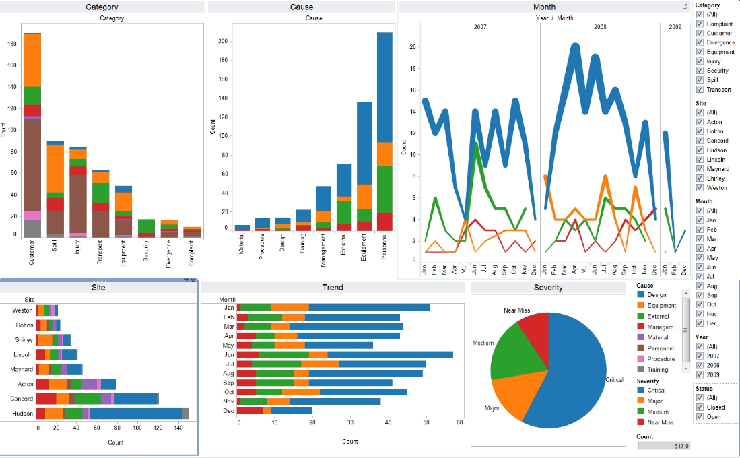

Image:1 Data visualization of electronics manufacturing market Reference: [data_visualization_python.jpg (1658×1026) (wp.com)](https://i1.wp.com/www.simplifiedpython.net/wp-content/uploads/2018/07/data_visualization_python.jpg?resize=1658%2C1026&ssl=1)

**Appendix A**

**Project Code**

**Home Page Source Code**

<!DOCTYPE html>

<html lang="en">

<head>

    <meta charset="UTF-8">

    <meta http-equiv="X-UA-Compatible" content="IE=edge">

    <meta name="viewport" content="width=device-width, initial-scale=1.0">

    <title>TravelHimalayas</title>

    <link rel="stylesheet" href="https://cdnjs.cloudflare.com/ajax/libs/font-awesome/6.3.0/css/all.min.css">

    <link rel="stylesheet" href="style.css">

    <link rel="stylesheet" href="website weather css.css">

</head>

<body>

  <!-- nav bar Start -->

    <nav>

      <div class="menu-icon">

          <span class="fas fa-bars"></span>

      </div>

      <div class="logo">

        TravelHimalayas

      </div>

      <div class="nav-items">

          <li><a href="#">Home</a></li>

          <li><a href="website weather.html">Weather</a></li>

          <li><a href="suggestion.html">suggestion</a></li>

          <li><a href="gallery.html">Gallery</a></li>

          <li><a href="Aboutus.html">About us</a></li>

          <li><a href="contactus1.html">Contact us</a></li>

      </div>

      <div class="search-icon">

          <span class="fas fa-search"></span>

      </div>

      <div class="cancel-icon">

          <span class="fas fa-times"></span>

      </div>

      <form action="#">

          <input type="search" class="search-data" placeholder="Search" required>

          <button type="submit" class="fas fa-search"></button>

      </form>

    </nav>

  <!-- nav bar End -->

    <div class="container"></div>

    <div class="a2">

        <h5>Build Your Next Holiday Trip With us </h5>

        <p><h1>Create<b>Your Tour</b></h1></p>

        <button type="button" class="btn btn-primary">Get in touch</button>

    </div>

    <!--<iframe width="860" height="500"  src="https://www.youtube.com/embed/CaqJ65CIoMw" title="YouTube video player" frameborder="0" allow="accelerometer; autoplay; clipboard-write; encrypted-media; gyroscope; picture-in-picture; web-share" allowfullscreen></iframe>

    <audio controls src="audio.mp3"></audio>-->

    <!-- section Start -->

    <section class="section">

        <div class="wrapper">

          <div class="card">

              <img src="pick/home2.jpeg" alt="">

              <div class="info">

                  <h><b>Kedarnath</b></h></h1>

                  <p>Among the glorious mountain peaks that are covered with nothing but snowstorm, lies one of the holiest pilgrim sites of northern India -"Kedarnath". Famous for the ancient shrine devoted to Lord Shiva, it tenders an unflustered ambience with its colorful rhododendron woods, snow covered mountains and splendid sights of nature.</p>

                  <a href="#" class="btn">Read More</a>

              </div>

          </div>

          <div class="card">

            <img src="pick/home3.jpeg" alt="">

              <div class="info">

                  <h1><b>Manali<b></h1>

                  <p>A gift of the Himalayas to the world, Manali is a beautiful township nestled in the picturesque Beas River valley. It is a rustic enclave known for its cool climate and snow-capped mountains, offering respite to tourists escaping scorching heat of the plains.30-Apr-2019A</p>

                  <a href="#" class="btn">Read More</a>

              </div>

          </div>

          <div class="card">

              <img src="pick/map3.jpg" alt="">

              <div class="info">

                  <h1><b>Valley of flower</b></h1>

                  <p>Arisaema tortuosum, Arisaema propinquum, Arisaema jaquemontii, Valley of Flowers trek, Uttarakhand. Snake flower Arisaema consanguineum (Himalayan Cobra Lily).</p>

                  <a href="#" class="btn">Read More</a>

              </div>

          </div>

      </div>

    </section>

       <section class="section2">

        <div class="wrapper">

          <div class="card">

              <img src="pick/ladhakpicks.jpg" alt="">

              <div class="info">

                  <h><b>Ladakh</b></h></h1>

                  <p>The word 'Ladakh,' known in Tibetan as 'La-dvags,' means 'the land of high passes. ' With an average height of more than ten thousand feet and numerous snow-capped peaks and glaciers, Ladakh is a high-altitude cold desert. The region boasts of a unique climatic condition..</p>

                  <a href="#" class="btn">Read More</a>

              </div>

          </div>

          <div class="card">

              <img src="pick/MANALI.jpg" alt="">

              <div class="info">

                  <h1><b>Manali<b></h1>

                  <p>Manali is a high-altitude Himalayan resort town in India’s northern Himachal Pradesh state. It has a reputation as a backpacking center and honeymoon destination. Set on the Beas River, it’s a gateway for skiing in the Solang Valley and trekking in Parvati Valley. It's also a jumping-off point for paragliding, rafting and mountaineering in the Pir Panjal mountains, home to 4,000m-high Rohtang Pass.</p>

                  <a href="#" class="btn">Read More</a>

              </div>

          </div>

          <div class="card">

              <img src="pick/valley1.jpg" alt="">

              <div class="info">

                  <h1><b>kashmir</b></h1>

                  <p>Kashmir is the northernmost geographical region of the Indian subcontinent. Until the mid-19th century, the term "Kashmir" denoted only the Kashmir Valley between the Great Himalayas and the Pir Panjal Range. </p>

                  <a href="#" class="btn">Read More</a>

              </div>

          </div>

      </div>

    </section>

    <!-- section End -->

    <footer>

      <div class="footer-right">

        <a href="#"><i class="fa-brands fa-facebook "></i></a>

        <a href="#"><i class="fa-brands fa-twitter"></i></a>

        <a href="#"><i class="fa-brands fa-linkedin-in"></i></a>

        <a href="#"><i class="fa-brands fa-github"></i></a>

      </div>

      <div class="footer-left">

        <p class="footer-links">

          <a class="link-1" href="#">Home</a>

          <a href="#">Blog</a>

          <a href="#">Pricing</a>

          <a href="#">About</a>

          <a href="#">Faq</a>

          <a href="#">Contact</a>

        </p>

        <p>Company Name &copy; 2015</p>

      </div>

    </footer>

       <!--javasceript topics-->

    <!-- <script>

      const menuBtn = document.querySelector(".menu-icon span");

      const searchBtn = document.querySelector(".search-icon");

      const cancelBtn = document.querySelector(".cancel-icon");

      const items = document.querySelector(".nav-items");

      const form = document.querySelector("form");

      menuBtn.onclick = ()=>{

        items.classList.add("active");

        menuBtn.classList.add("hide");

        searchBtn.classList.add("hide");

        cancelBtn.classList.add("show");

      }

      cancelBtn.onclick = ()=>{

        items.classList.remove("active");

        menuBtn.classList.remove("hide");

        searchBtn.classList.remove("hide");

        cancelBtn.classList.remove("show");

        form.classList.remove("active");

        cancelBtn.style.color = "#ff3d00";

      }

      searchBtn.onclick = ()=>{

        form.classList.add("active");

        searchBtn.classList.add("hide");

        cancelBtn.classList.add("show");

      }

    </script> -->

</body>

</html>

Appendix B Screenshot of Project

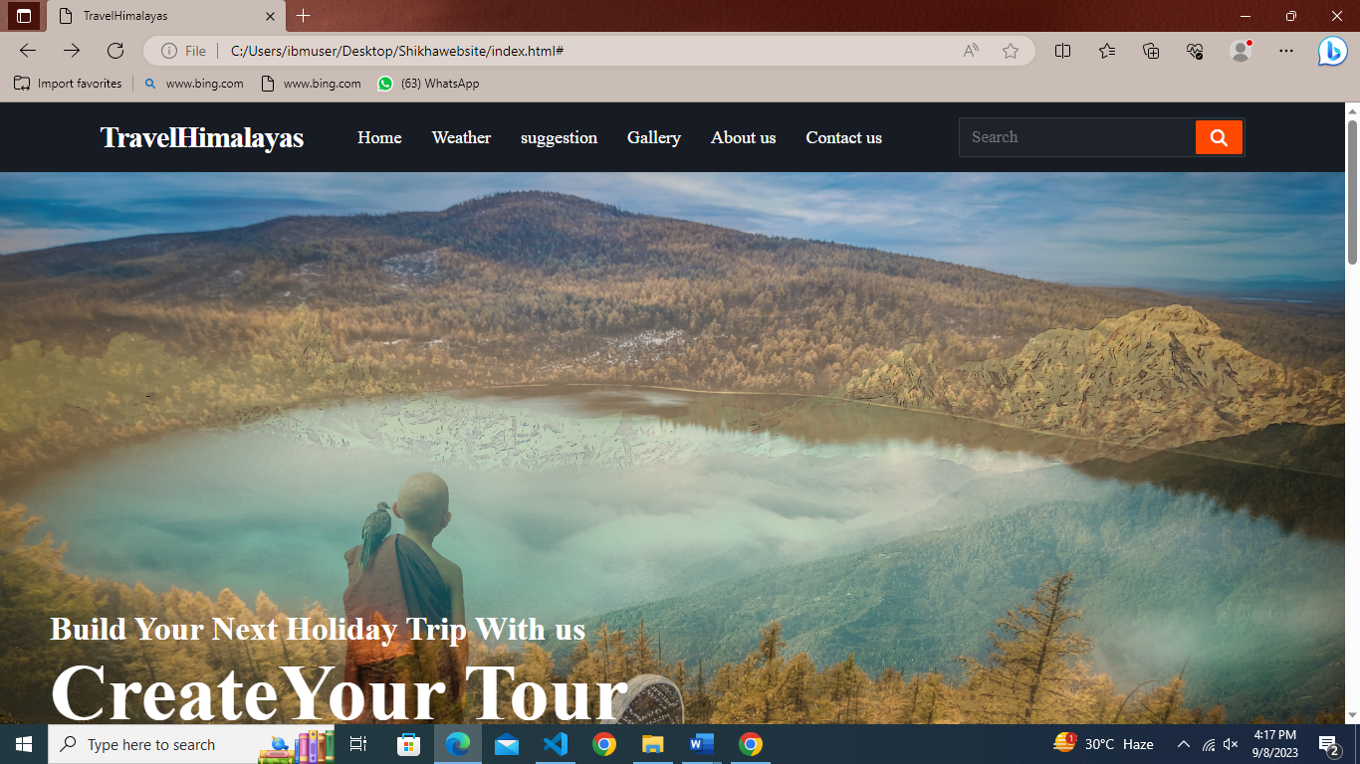

Website Laptop View

Full Page Screenshot

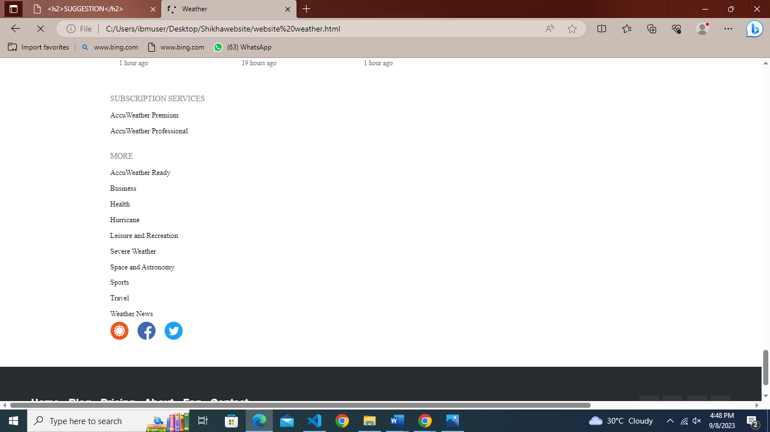

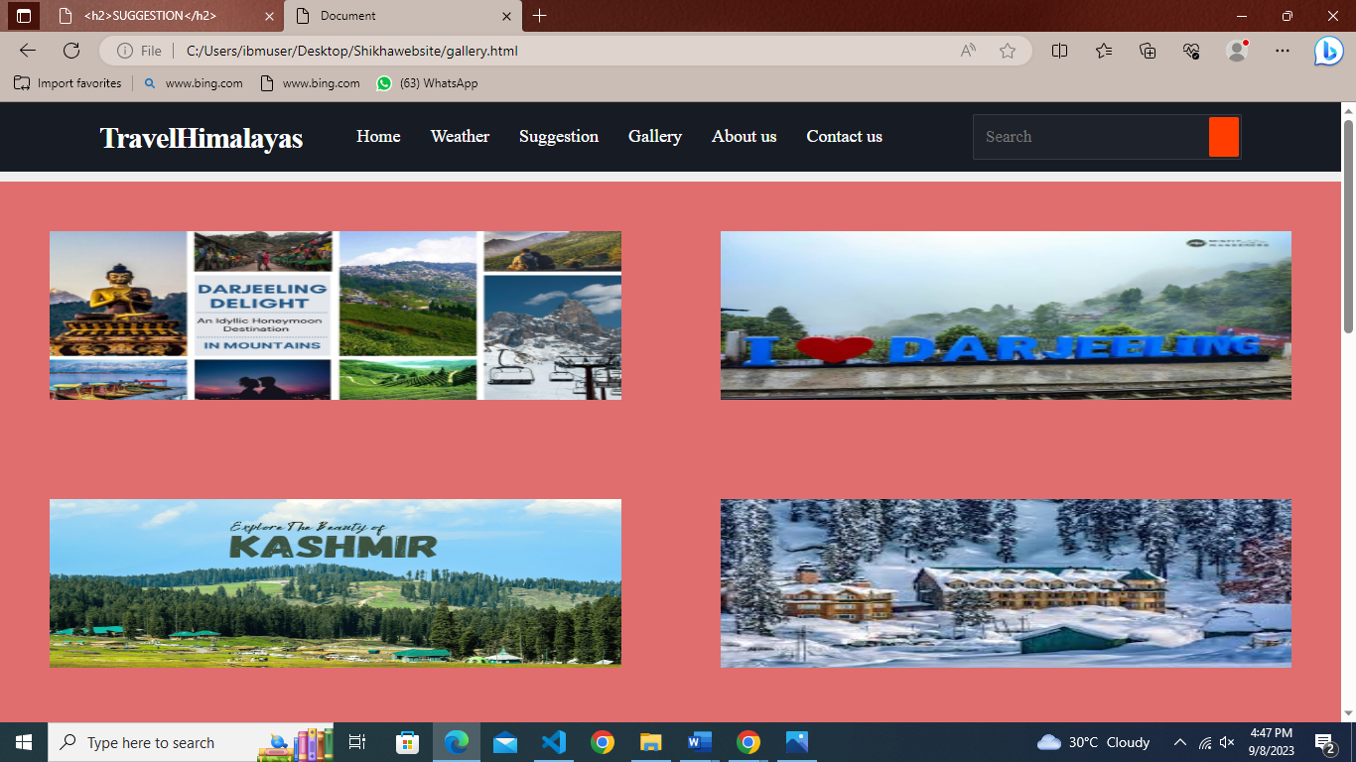

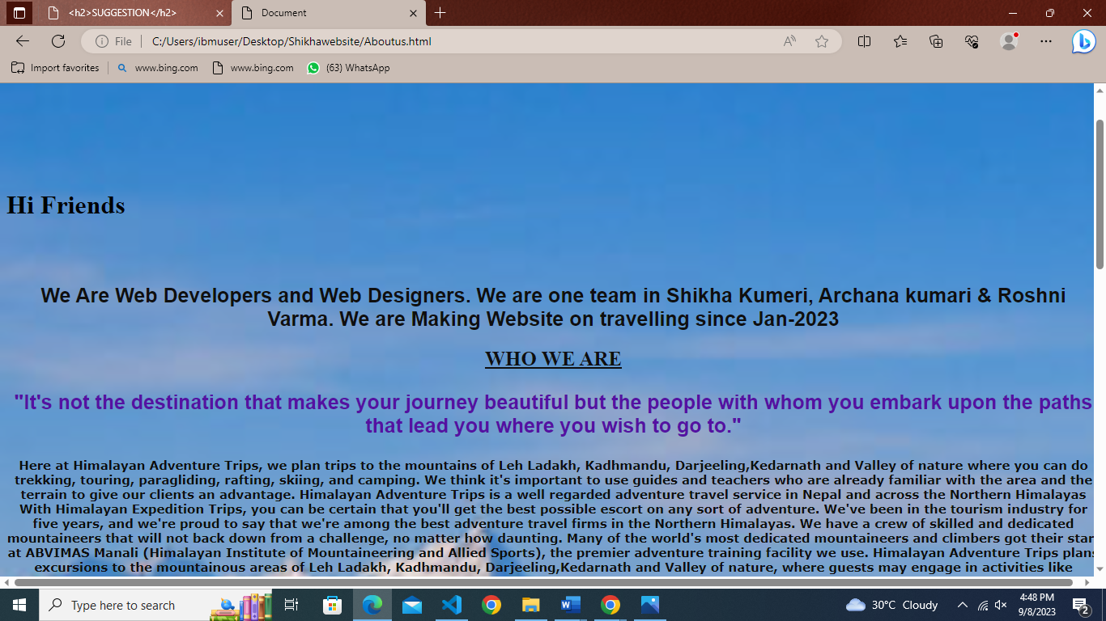

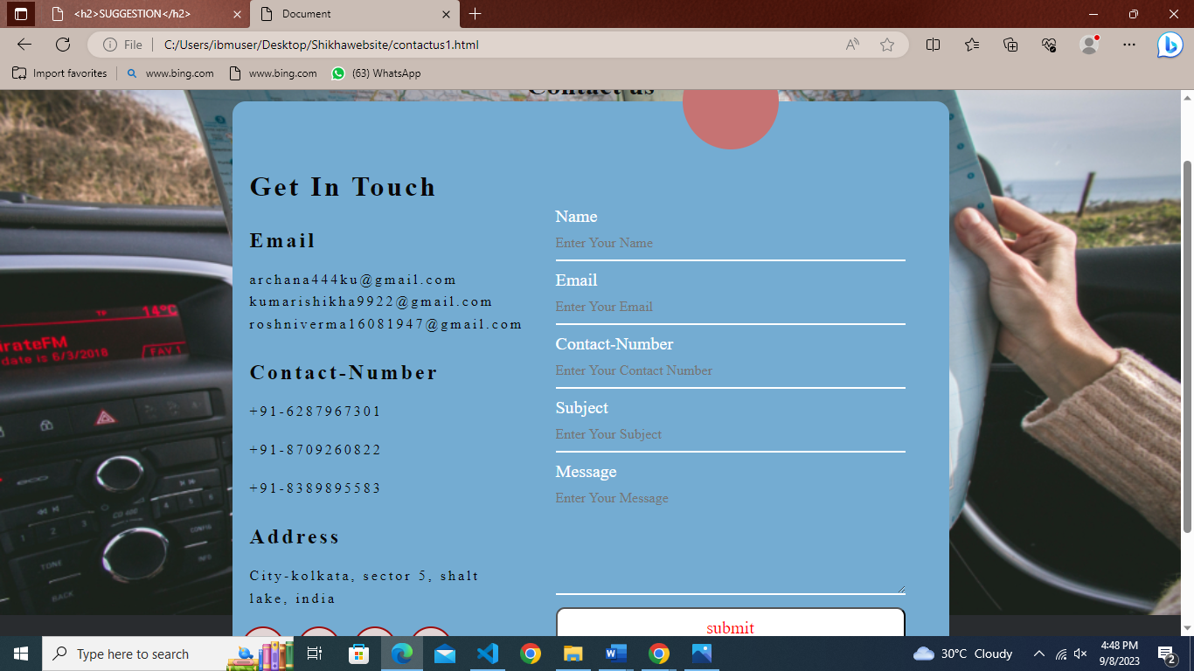

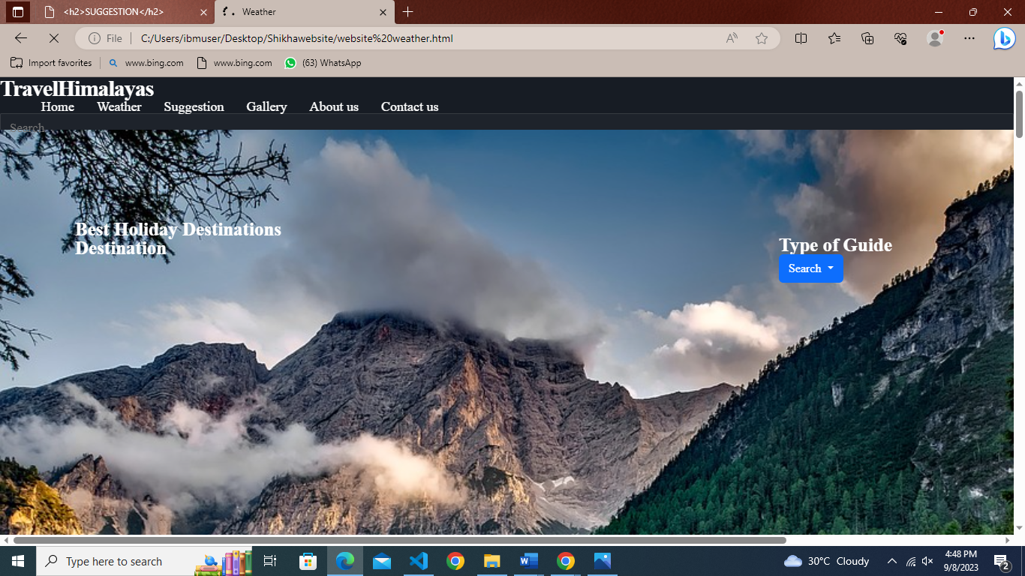

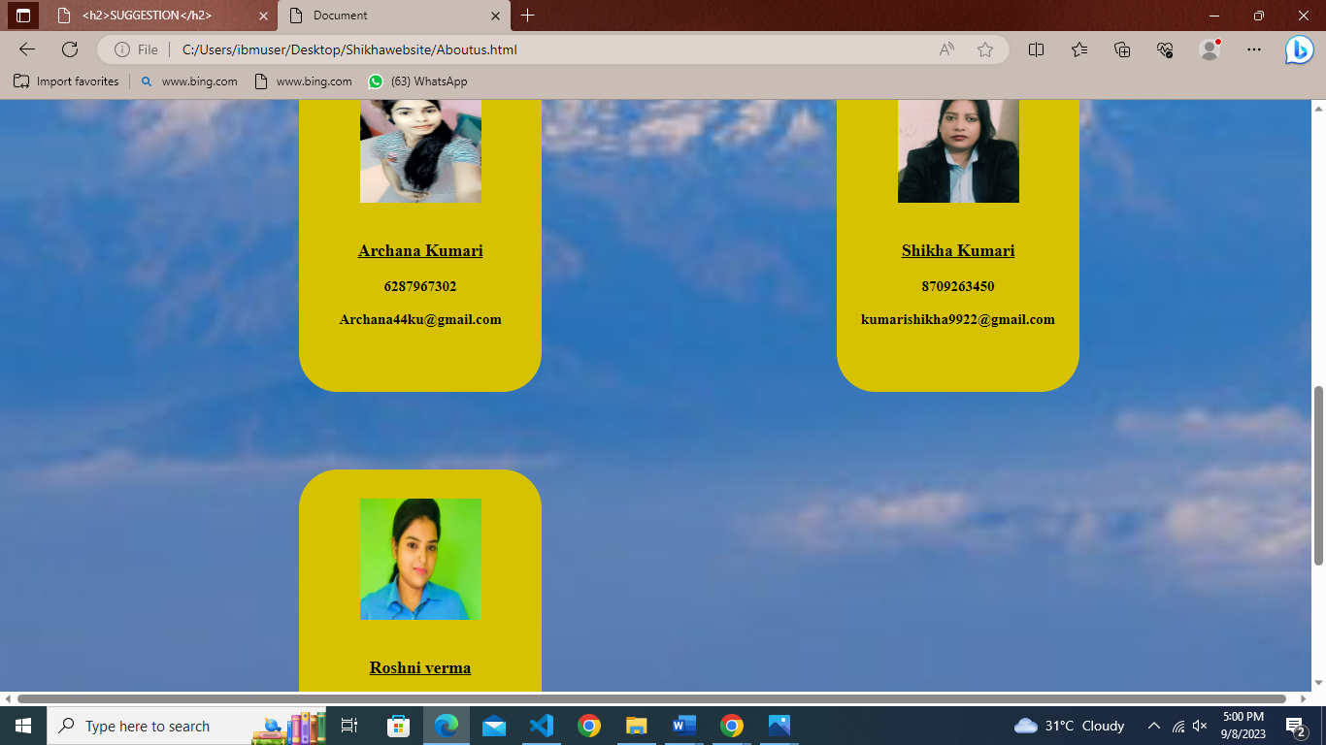

Thank You